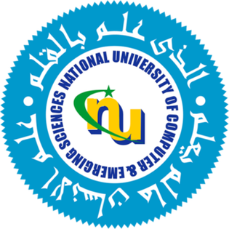

National University of Computer and Emerging Sciences
(Karachi Campus)
FAST School of Computing
Fall 2024

Project Proposal : [ GUI Based Tic Tac Toe ]

Abstract:-
[This application is designed for a classic Tic Tac Toe game. It incorporates collaborative efforts from every team member to create an engaging and user-friendly experience. The game is multiplayer and features a graphical user interface (GUI), making it a fun and interactive way to enjoy this timeless game. Our aim is to enhance the user experience exponentially.]

Group Members:

Mohammad Taha Anwer (Group Leader) - 24k-3033
Syed Sultan Ahmed - 24k-0585
Yash Raj - 24k-0737

Remarks:

⃞ Approved ⃞ Not Approved

